

COVID-19 Vaccination and Cases Dashboard Report



Name Samiya  
Roll No 201980030

Subject Data Warehouse

Contents

**1. Dataset Overview** 3

**Data Source** 3

**Key Columns in the Dataset** 6

**Column Name** 6

**Description** 6

**Confirmed** 6

The total number of confirmed COVID-19 cases on that date 6

**Deaths** 6

The number of deaths due to COVID-19 reported on that date 6

**First Dose Administered** 6

The number of first doses of the vaccine administered 6

**Second Dose Administered** 6

The number of second doses of the vaccine administered 6

**Age Group** 6

The age group of vaccinated individuals (e.g., 0-19, 20-29, 30-39, etc.) 6

**Gender** 6

The gender of vaccinated individuals (Male, Female, or Other) 6

**Covishield** 6

The number of Covishield vaccine doses administered 6

**Covaxin** 6

The number of Covaxin vaccine doses administered 6

**Sputnik V** 6

The number of Sputnik V vaccine doses administered 6

**2. Visualization Explanation** 6

**A. COVID-19 Cases vs. Deaths Over Time** 7

**B. First vs. Second Dose Administered** 8

**C. Doses Administered by Vaccine Type** 9

**D. Age Group Distribution of Vaccination** 11

**E. Gender Distribution of Vaccination** 12

**F. COVID-19 Deaths by State** 14

**3. Dashboard Overview** 15

**Layout and Interaction** 15

**User Interaction** 15

**4. Reflection on the Process** 17

**1. Data Cleaning & Preparation** 17

**2. Choosing the Right Visualizations** 17

**3. Designing an Intuitive Dashboard** 17

**6. Conclusion** 17

**1. Dataset Overview**

**Data Source**

The data used for this report is sourced The dataset includes COVID-19 vaccination details, case numbers, deaths, and demographic information about vaccinated individuals. The data is structured to allow analysis of trends, comparisons, and insights into vaccination efforts and COVID-19 case severity.

**Covid_19_india**

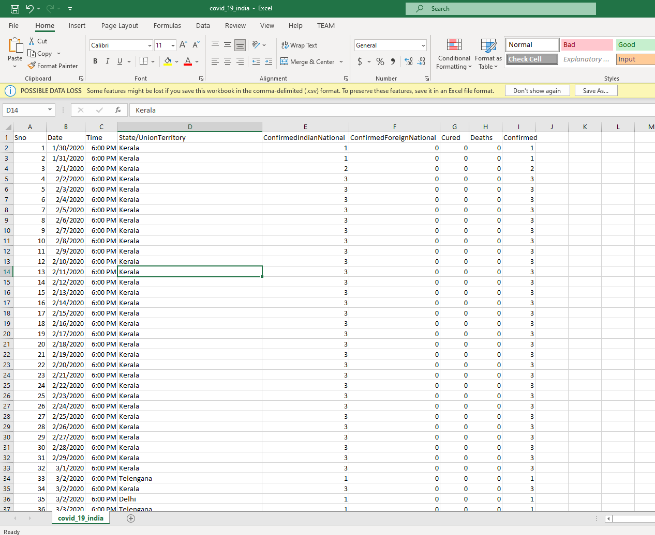

**Covid_vaccine_statewise**

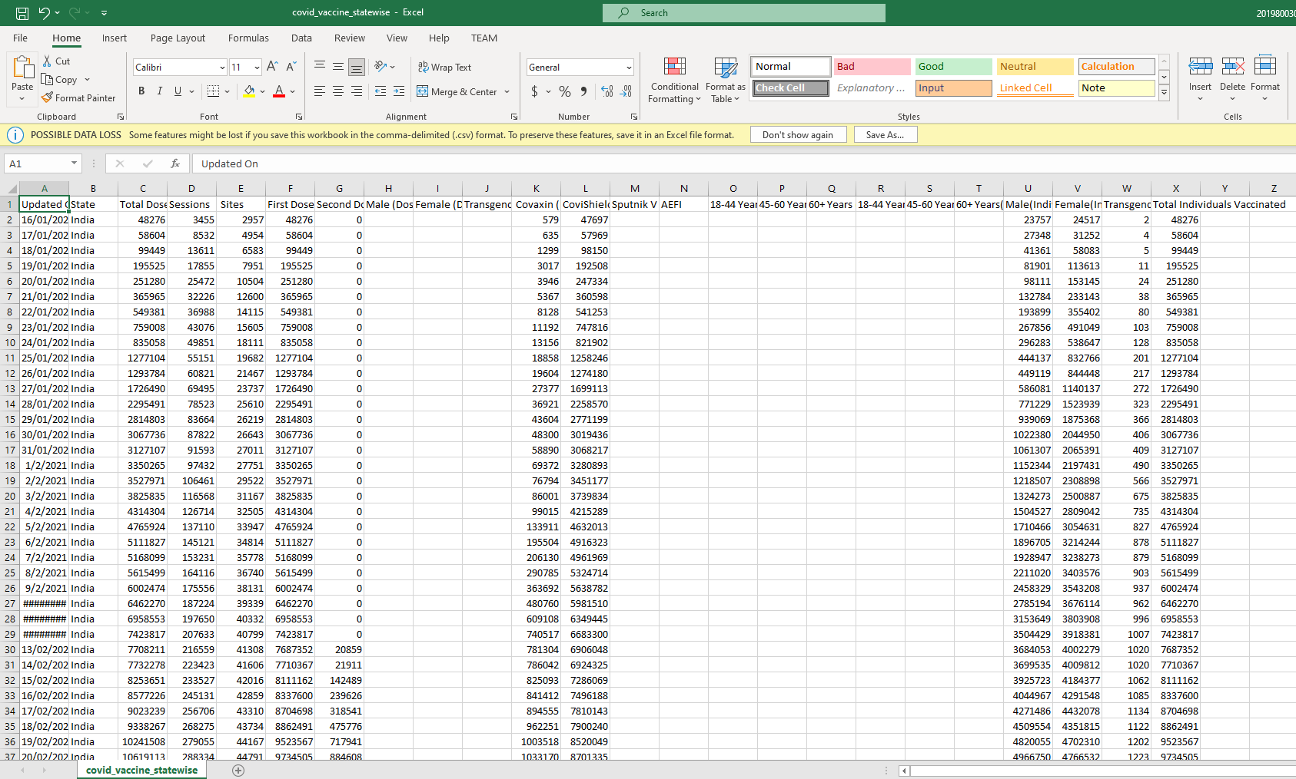

**AgeGroupDetails**

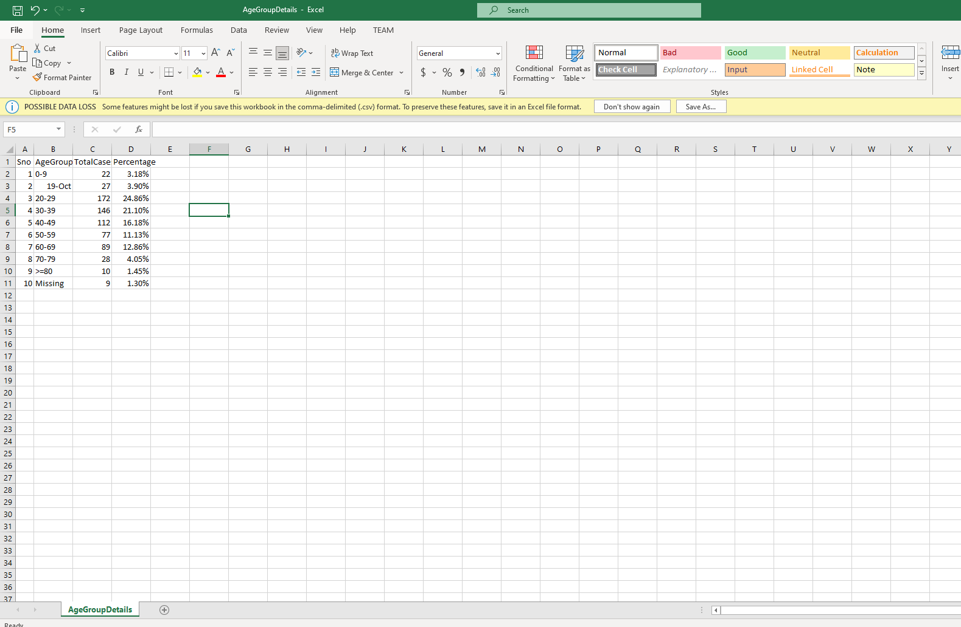

**India_State_Boundary**

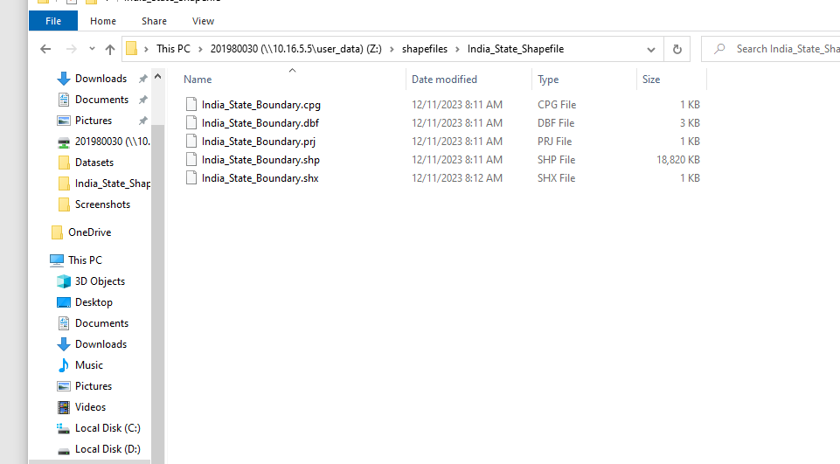

**IndividualDetails**

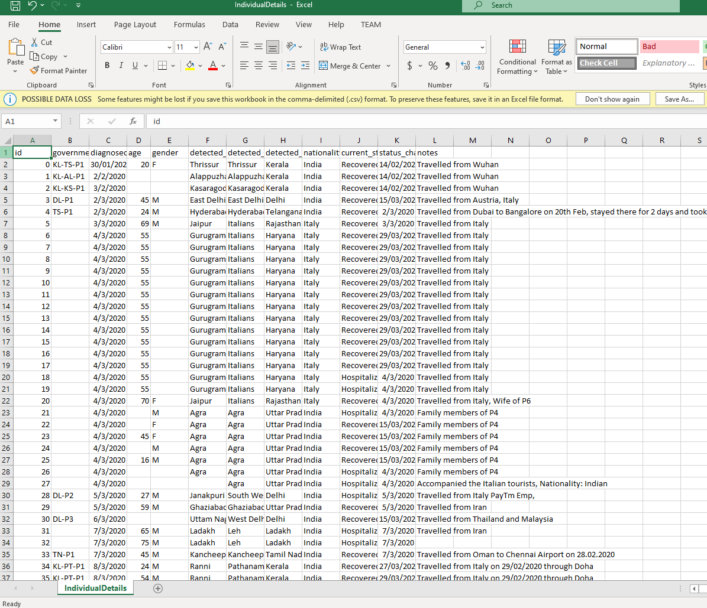

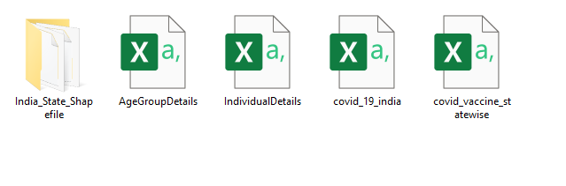

**Key Columns in the Dataset**

|  |  |
| --- | --- |
| **Column Name** | **Description** |
| **Confirmed** | The total number of confirmed COVID-19 cases on that date |
| **Deaths** | The number of deaths due to COVID-19 reported on that date |
| **First Dose Administered** | The number of first doses of the vaccine administered |
| **Second Dose Administered** | The number of second doses of the vaccine administered |
| **Age Group** | The age group of vaccinated individuals (e.g., 0-19, 20-29, 30-39, etc.) |
| **Gender** | The gender of vaccinated individuals (Male, Female, or Other) |
| **Covishield** | The number of Covishield vaccine doses administered |
| **Covaxin** | The number of Covaxin vaccine doses administered |
| **Sputnik V** | The number of Sputnik V vaccine doses administered |

This dataset allows us to analyze the effectiveness and reach of the COVID-19 vaccination program by examining the distribution of vaccines among different age groups, gender, and time periods. Additionally, it provides insights into COVID-19 trends, highlighting case spikes and death rates.

**2. Visualization Explanation**

The dashboard consists of multiple visualizations designed to provide meaningful insights into the pandemic’s impact and vaccination efforts.

**A. COVID-19 Cases vs. Deaths Over Time**

**Visualization Type: Dual Line Chart**

**Purpose:**

This line chart displays the trends of confirmed COVID-19 cases and deaths over time. It helps in understanding the fluctuations in case numbers and mortality rates.

**Insights:**

* The number of confirmed cases and deaths follows similar trends, with peaks and troughs occurring together.
* A sharp increase in cases corresponds to a rise in deaths, indicating the severity of certain COVID-19 waves.
* The highest peaks likely correspond to major waves, such as the second wave in mid-2021.
* This visualization helps in assessing the correlation between case surges and fatality rates.

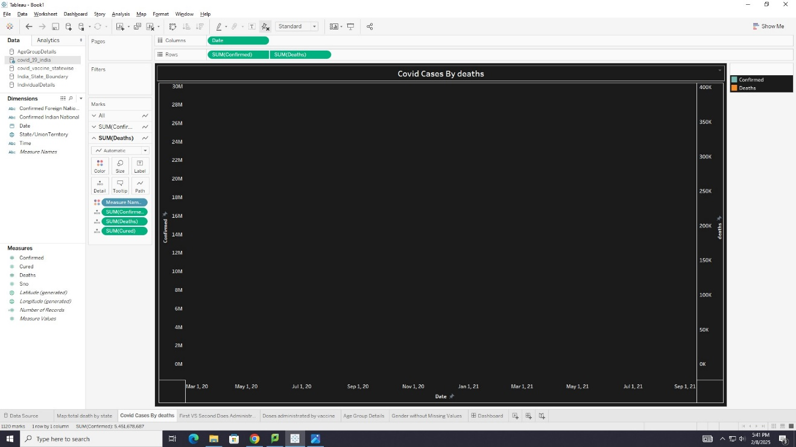

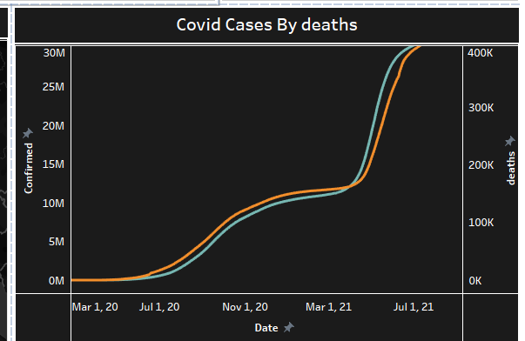

**B. First vs. Second Dose Administered**

**Visualization Type: Bar Chart**

**Purpose:**

This bar chart compares the total number of first doses and second doses administered over time. It highlights gaps in vaccination completion.

**Insights:**

* A significantly higher number of first doses have been administered compared to second doses.
* This suggests that many individuals may have started but not completed their vaccination schedule.
* The vaccination program may need to focus on improving second-dose administration to ensure full immunization.

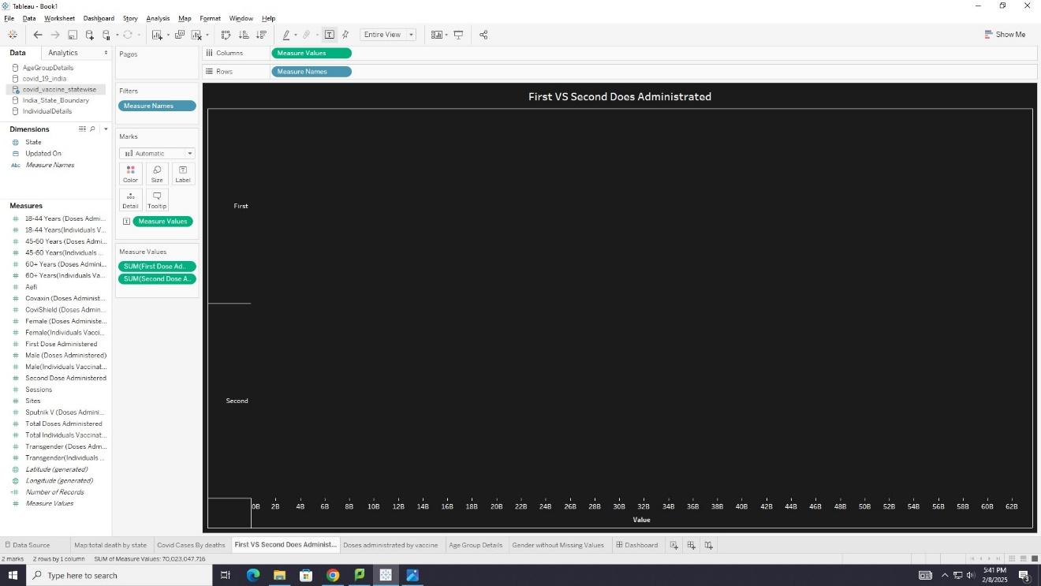

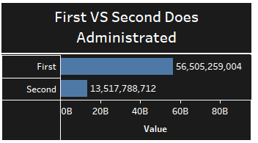

**C. Doses Administered by Vaccine Type**

**Visualization Type: Horizontal Bar Chart**

**Purpose:**

This bar chart illustrates the total number of vaccine doses administered by type (Covishield, Covaxin, and Sputnik V).

**Insights:**

* **Covishield** is the most administered vaccine, followed by **Covaxin**, while **Sputnik V** has the least number of doses administered.
* This visualization helps in understanding vaccine preference and distribution across the region.
* Government policies and supply constraints may have influenced the preference for Covishield.

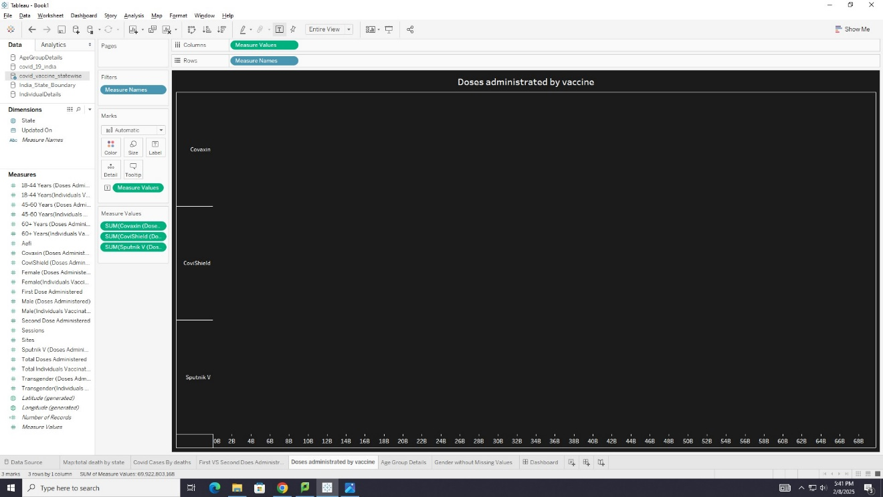

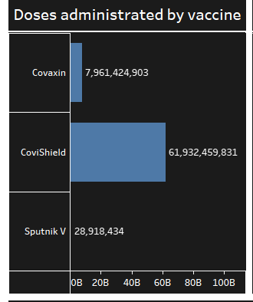

**D. Age Group Distribution of Vaccination**

**Visualization Type: Donut Chart**

**Purpose:**

This chart represents the percentage distribution of vaccinated individuals across different age groups.

**Insights:**

* The majority of vaccinations are seen in the **20-29** and **30-39** age groups.
* This suggests that younger adults were more proactive in getting vaccinated, possibly due to job requirements or increased awareness.
* The vaccination rate among the elderly is lower, which could indicate accessibility challenges or vaccine hesitancy in older populations.

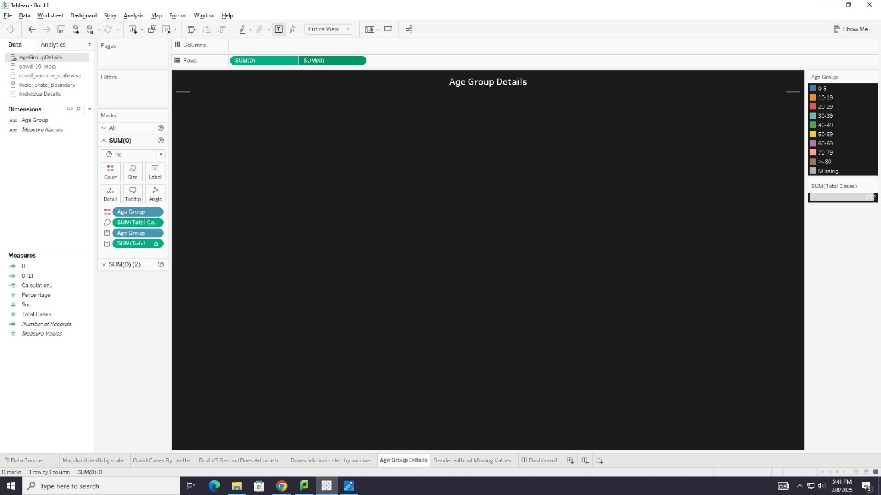

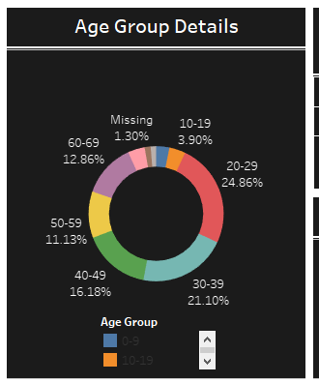

**E. Gender Distribution of Vaccination**

**Visualization Type: Pie Chart**

**Purpose:**

This chart visualizes the gender distribution of vaccinated individuals.

**Insights:**

* Males account for **66.76%** of vaccinations, while females account for **33.24%**.
* This highlights a gender gap in vaccination rates, which may be due to cultural, logistical, or societal factors.
* Policies should be aimed at increasing vaccine accessibility for women.

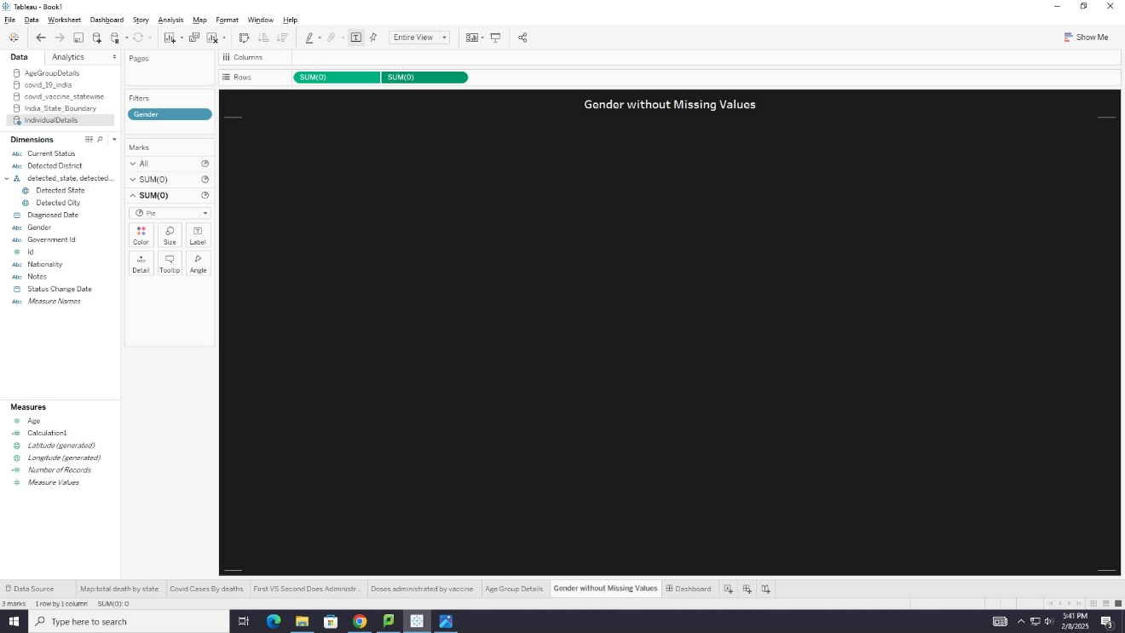

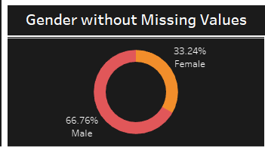

**F. COVID-19 Deaths by State**

**Visualization Type: Map**

**Purpose:**

This map represents the total number of COVID-19 deaths by state in India.

**Insights:**

* **Maharashtra, Uttar Pradesh, and Delhi** report the highest number of deaths.
* **Northeastern states** show lower fatality rates, likely due to lower population density or effective containment measures.
* This visualization helps in identifying high-risk areas and allocating healthcare resources efficiently.

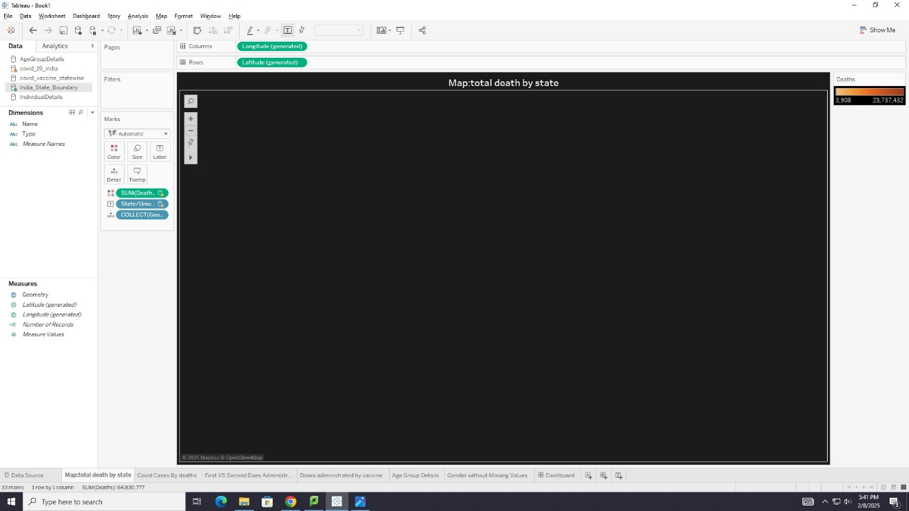

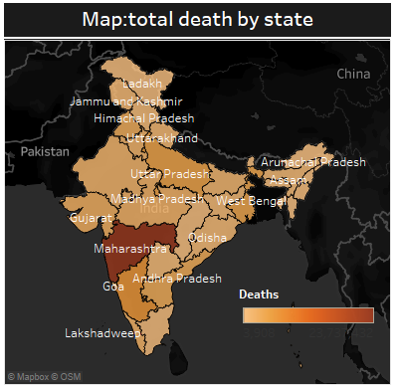

**3. Dashboard Overview**

**Layout and Interaction**

The dashboard is structured in a logical flow to allow easy navigation and analysis:

1. **Vaccine Data at the Top:** Users can see an overview of doses administered by vaccine, age group, and gender.
2. **State-wise Analysis in the Middle:** The map provides geographical insights into deaths per state.
3. **Time-Series Data at the Bottom:** The line chart helps users analyze trends over time.

**User Interaction**

* **Hover Effects:** Users can hover over charts to see detailed tooltips with exact numbers.
* **Filters:** Users can apply filters to focus on specific states, age groups, or time periods.
* **Interactive Map:** The heatmap allows users to explore state-wise data by clicking on regions.

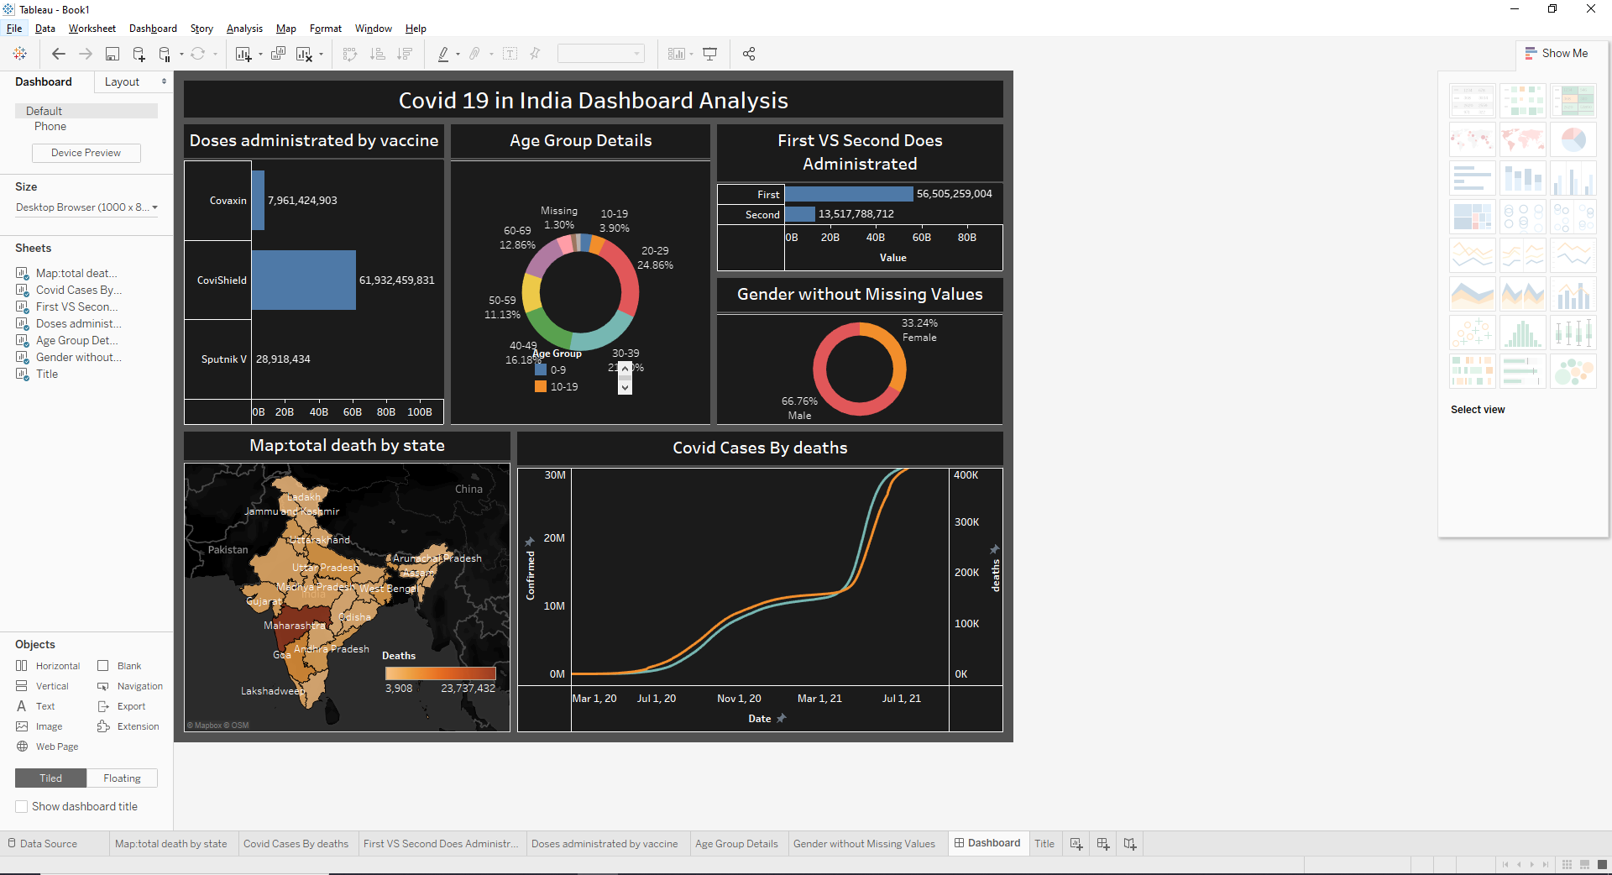

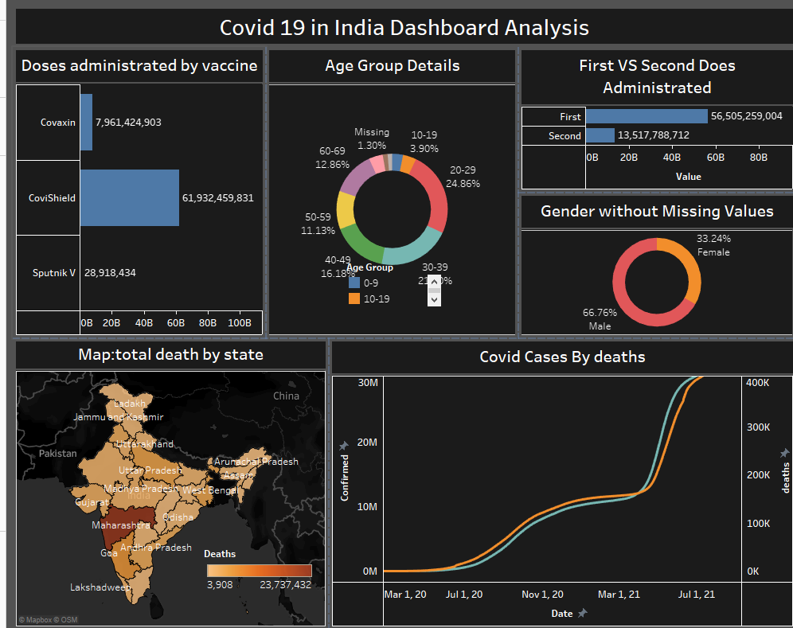

**4. Reflection on the Process**

Creating this dashboard involved several critical steps:

**1. Data Cleaning & Preparation**

* Handling missing values to ensure accurate representation.
* Structuring data into appropriate dimensions and measures.

**2. Choosing the Right Visualizations**

* Selecting charts that effectively communicate trends and comparisons.
* Using appropriate colors and layouts to enhance readability.

**3. Designing an Intuitive Dashboard**

* Ensuring a logical flow of information from general trends to specific insights.
* Adding filters and interactivity for deeper analysis.

**6. Conclusion**

This dashboard effectively visualizes the impact of COVID-19 by analyzing case trends, vaccination rates, and mortality statistics. The insights gained from these visualizations can help policymakers, healthcare professionals, and the general public understand the progress of the vaccination program and areas that need improvement.

Key takeaways include:

* **Covishield was the most widely used vaccine.**
* **The second-dose administration rate was significantly lower than the first dose.**
* **Males had a higher vaccination rate than females.**
* **Certain states faced significantly higher mortality rates.**
* **COVID-19 waves followed a distinct pattern of confirmed cases and deaths.**